Problem 1:

0 1 0

1 1 1 1🡪 is origin mask weights is 1

0 1 0

1/3 *[f(i-1,j),f(i,j),f(i+1,j)]+ 1/3 * [f(i,j-1),f(i,j),f(I,j+1)]

=

1/9 *[f(i-1,j-1),f(i-1,j),f(i-1,j+1),f(i,j-1),f(i,j),f(i,j+1),noisy_img(i+1,j-1),f(i+1,j),f(i+1,j+1)];

Likes:

f * [1,1,1] *1/3 + f* [1;1;1] *1/3 = f*[0,1,0;1,2,1;0,1,0] *1/6

The point will calculate 1/3 of the sum of the point above and the point below, then, it will calculate left one and right one. So, for the average the whole point, it weight is 1 in center.

Problem 2:

a) What is the resultant image of convolution (as defined in Eq. (3.4-2))?

|  |  |  |  |  |
| --- | --- | --- | --- | --- |
| 27 | 50 | 72 | 90 | 85 |
| 33 | 72 | 110 | 145 | 150 |
| 34 | 78 | 125 | 167 | 153 |
| 34 | 68 | 100 | 132 | 98 |

b) What is the resultant image of correlation (as defined in Eq. (3.4-1))?

|  |  |  |  |  |
| --- | --- | --- | --- | --- |
| 31 | 56 | 77 | 95 | 82 |
| 47 | 84 | 124 | 160 | 119 |
| 51 | 94 | 137 | 174 | 116 |
| 40 | 74 | 114 | 138 | 74 |

Problem 3:

1. Prove the important property that, if the coefficients of the mask sum to zero, then the sum of all the elements in the resulting convolution array will be zero also.

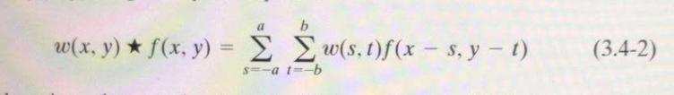

Any location(x,y) need convolution is consists of the centering mask point and sum of all the points multiply with mask coefficients with the corresponding pixels in the image. So, every pixel in the image will go through every coefficient and sum them together. If the coefficients sum to zero, it means the sum of the coefficients of location(x,y) also sum to zero. Then the sum of all the elements in the resulting convolution array will be zero also.

1. Yes, the result is the same. The sum of all the elements in the resulting correlation array will be zero. Because the only difference between convolution and correlation is the mask rotate 180 degree. The sum of the coefficient is zero will not effect the result. The correlation array will be zero.